**Credential Administrator**

**User Manual**





This document contains proprietary information of Wipro Ltd. No part of this publication may be reproduced, stored in a retrieval system or transmitted in any form or by any means, whether electronic, mechanical, photocopying, recording or otherwise, without the prior written permission of Wipro Ltd. The information contained herein is confidential between Wipro Ltd. and it’s Customers and shall not be distributed to any persons other than those involved in the assessment and delivery of services. Wipro Ltd. reserves the right to revise and update this document as and when required. Wipro Ltd. reserves the right to withdraw the document excluding customer specific information at the time of termination of services.

 All product names referenced herein are trademarks of their respective companies.

**Table of contents**

1. How to login to the Credential Administrator Portal………………………3
2. Mandatory Account Registration for new user…………………………….4-8
3. Password Reset & Account Unlock ……………………...………………..9-15
4. GAL Modification & Change Password…………………………………….16-19
5. Renew Account………………………………………………………………..20-22
6. Set Alternate Email ID………………………………………………………...23-24

**1. How to login to the Credential Administrator Portal**

**Access URL in Browser and enter the login credentials using employee ID and password along with corresponding Domain to login.**

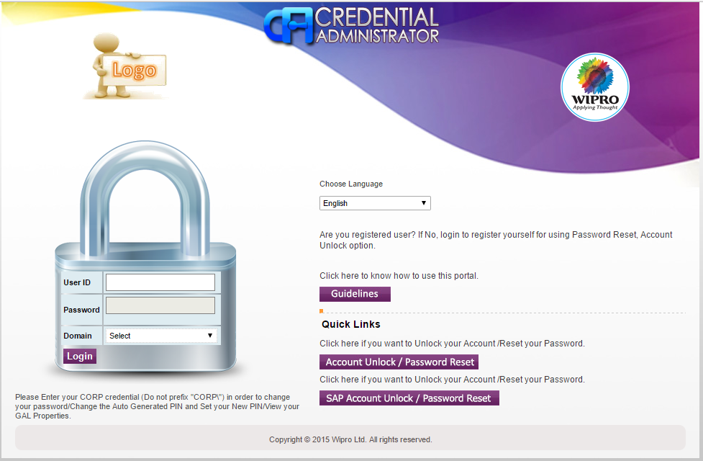

**2. Mandatory Account Registration for new user**

**Step1: For New user, once login, users will get below screen asking them to register themselves by setting PIN, Secret question & answer. Once click on ok, will be navigated to Home page**

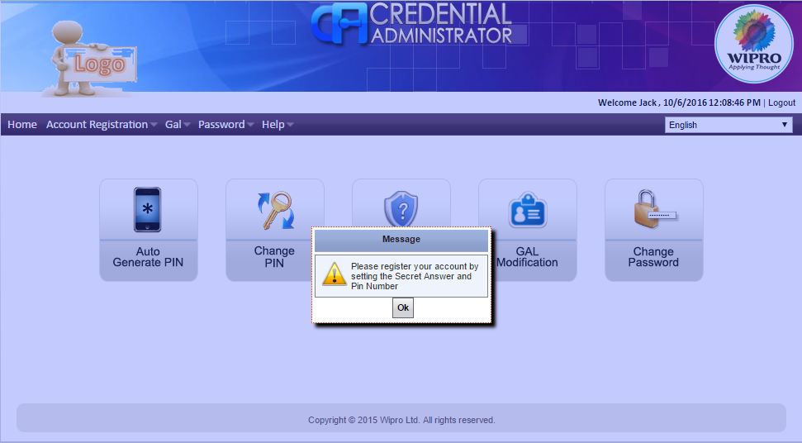

**Using “Account Registration” menu or “Auto Generate PIN” and “Set Secret questions and Answers” buttons users can register themselves.**

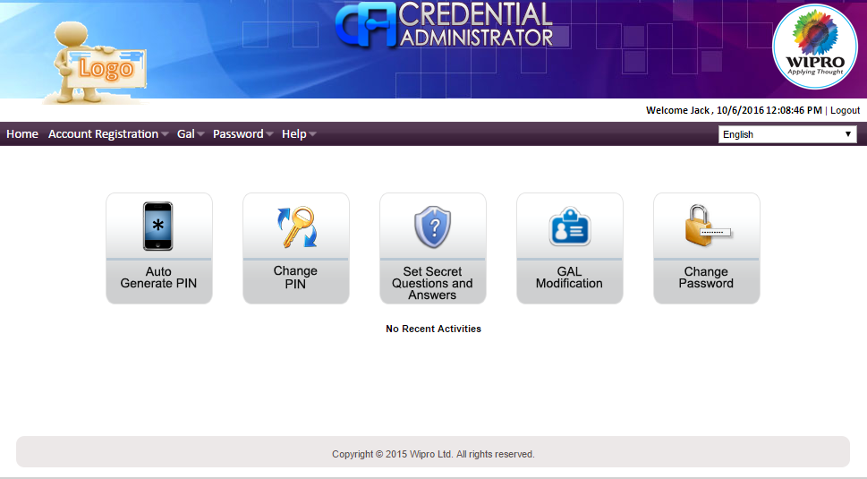

**Step2: Click on “Auto Generate PIN” image in Home page to generate new PIN number. PIN number will be displayed as a pop up message with expiry date as 30 days. Auto generated PIN should be taken to change PIN as user’s choice**

**Auto generate PIN**

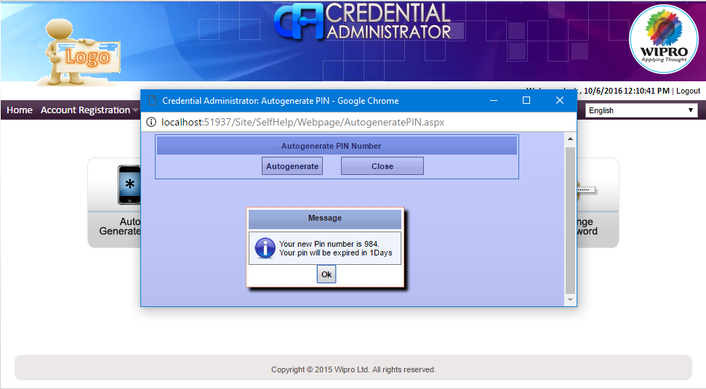

**Change PIN**

**Click on “Change PIN” button in Home page to change PIN as of user’s choice. Enter Current PIN which was auto generated and then New PIN and click on Reset**

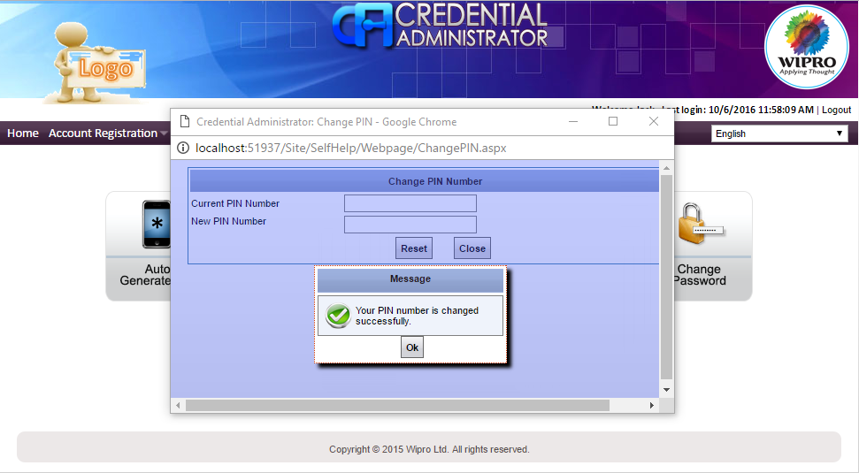

**Set Secret Question and Answer**

**Click on “Set Secret Question and Answers” image in Home page to set answers for default secret questions. Secret questions cannot be set with duplication.**

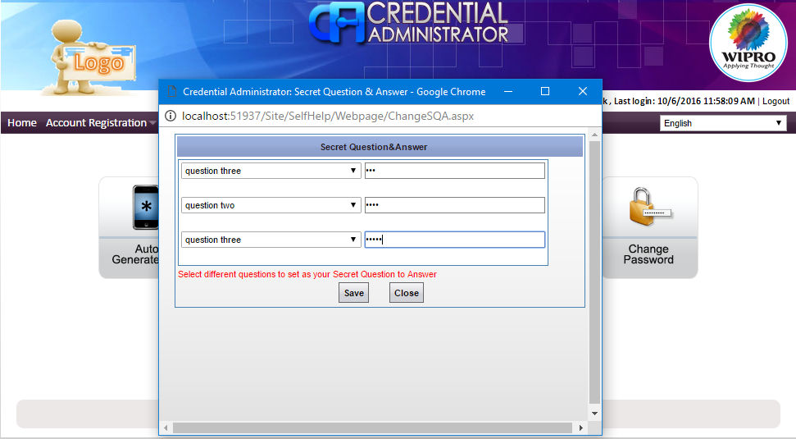

**3.Password Reset**

**Click on “Account Unlock/Password Reset” in login page to reset the password using PIN mechanism. For SAP related accounts, click on “SAP Account Unlock/Password Reset”.**



**Step1: Enter User ID and captcha image details and click on verify to proceed further**

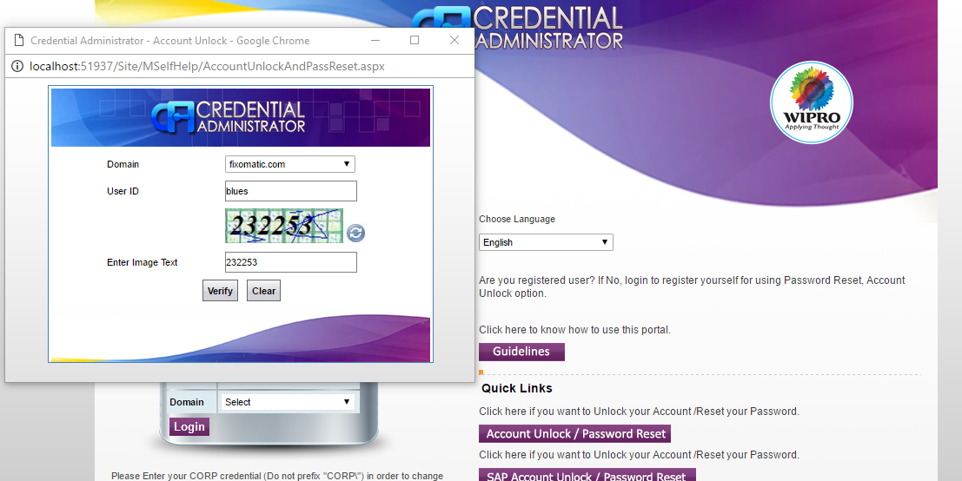

**Step2: Enter PIN number and click on validate**

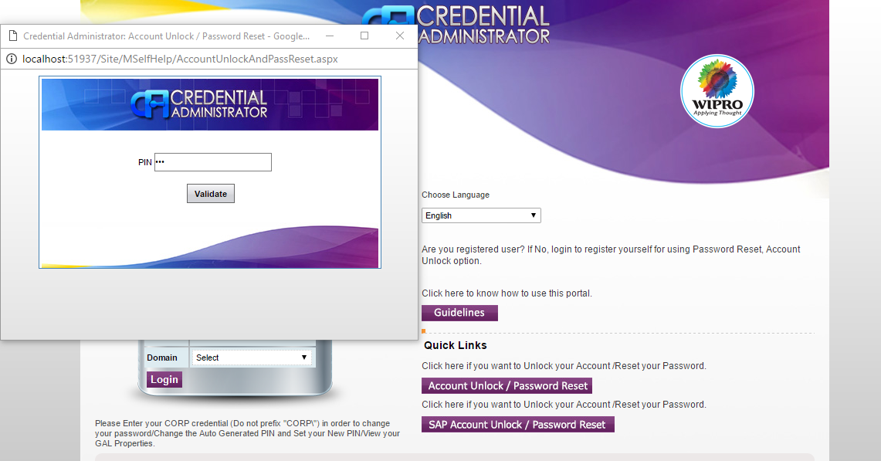

**Step3: Enter answer for randomly generated secret question and click on validate**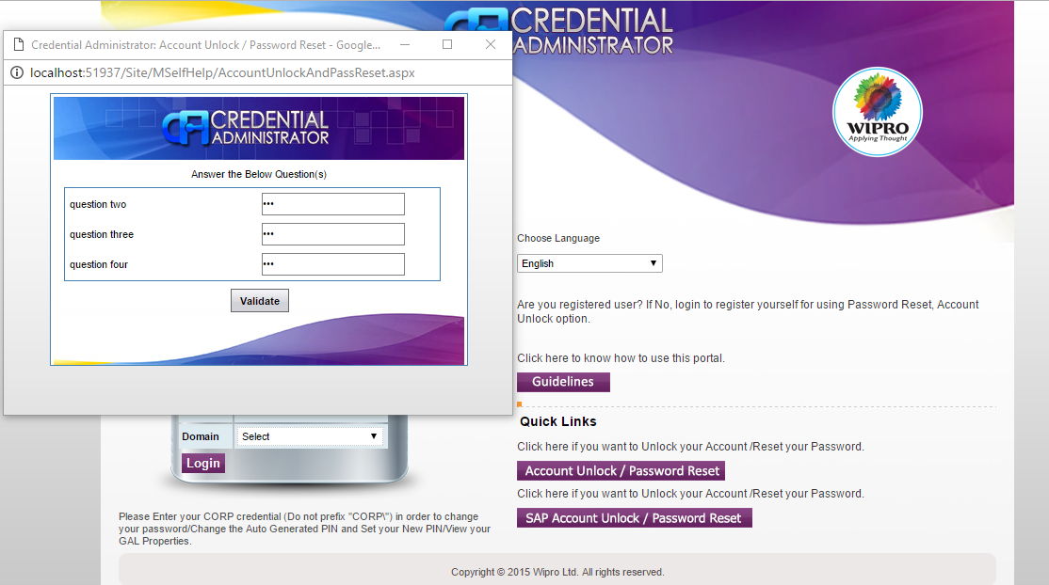

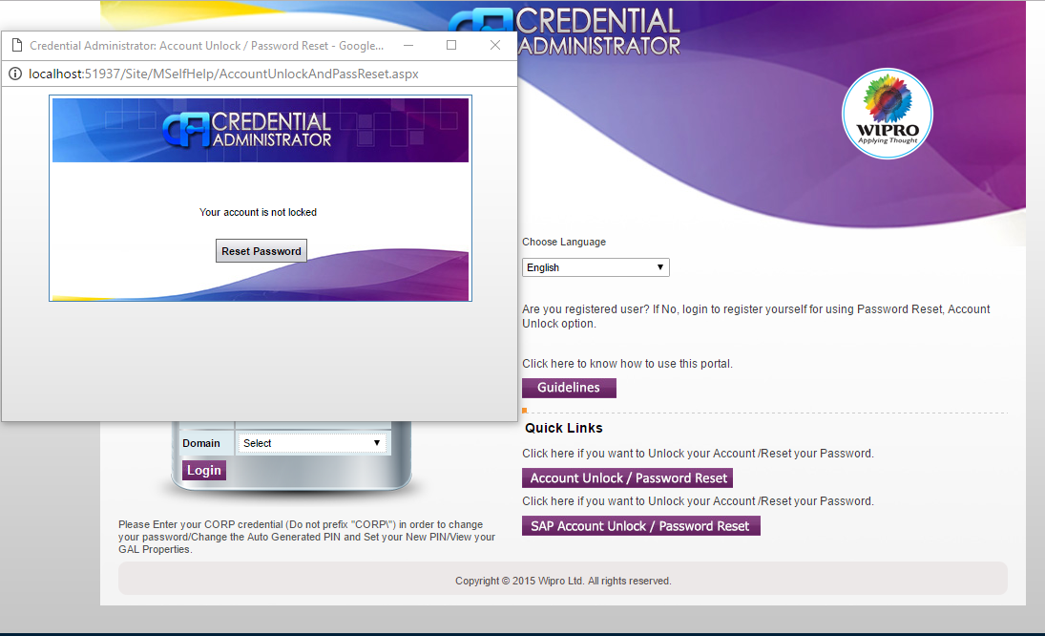

**Step4: Enter New Password and Confirm Password and click on Reset Password**

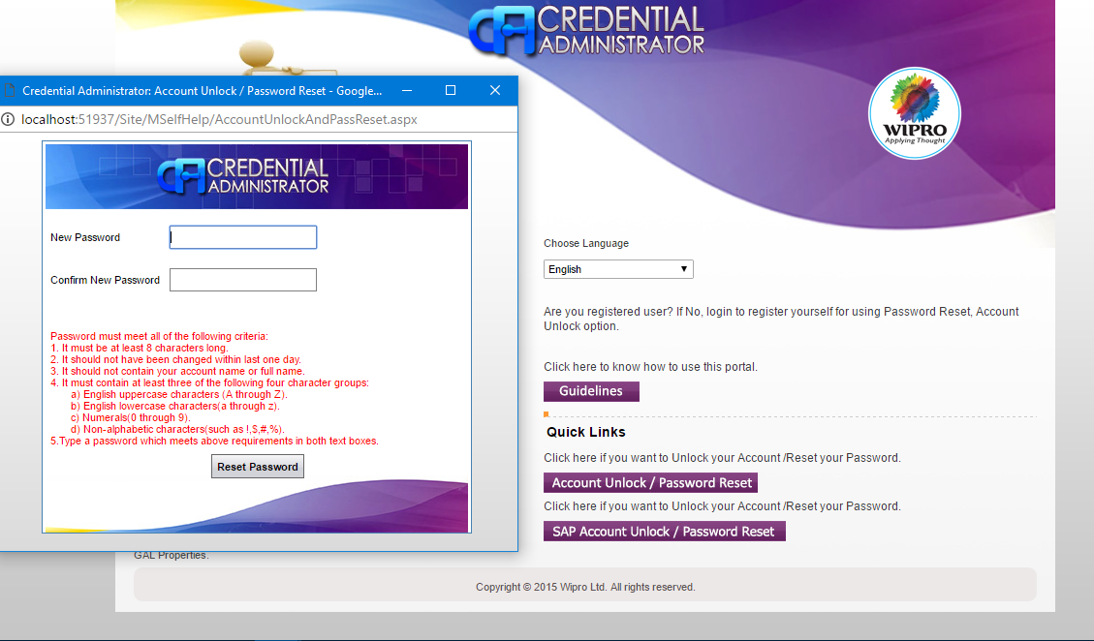

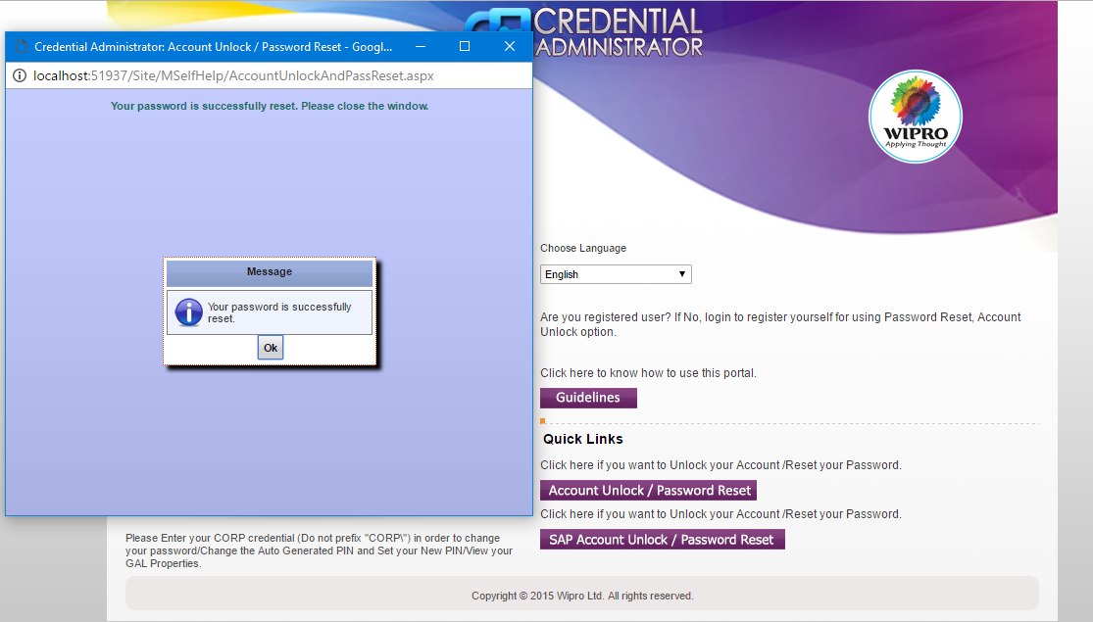

**Account Unlock**

**Click on “Account Unlock/Password Reset” in login page to unlock account with secured mechanism.**



**Step1: Enter User Id and captcha image details and click on verify to proceed further**



**Step2: Enter PIN number and click on validate**



**Step3: Enter answer for randomly generated secret question and click on validate. Account will be unlocked and display confirmation message**



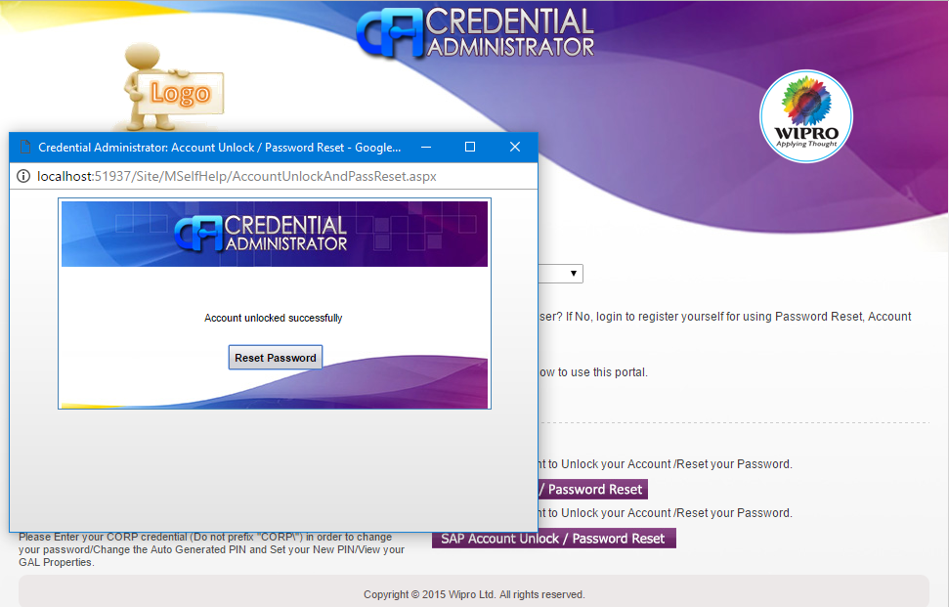

**4.GAL Modification**

**Steps: Click on “GAL Modification” in Home page and click on edit button to edit details in GAL modification page.**

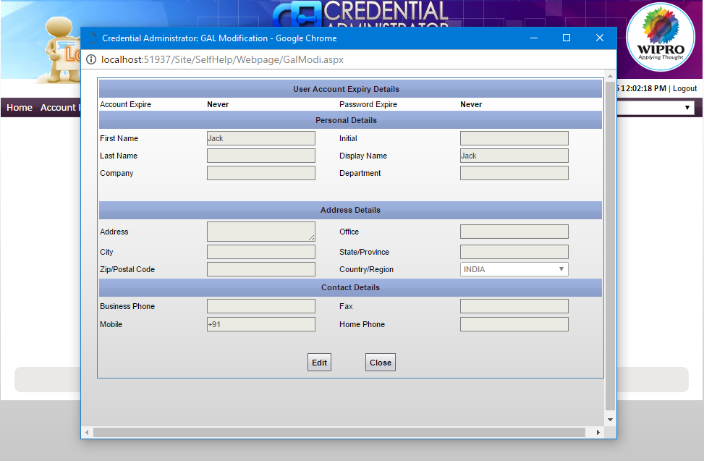

**Enter current password for the account and click on OK.**

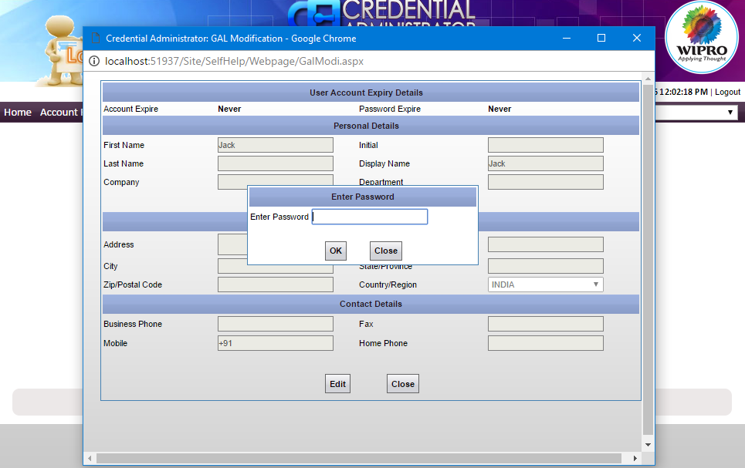

**Modify the details and click on update button.**

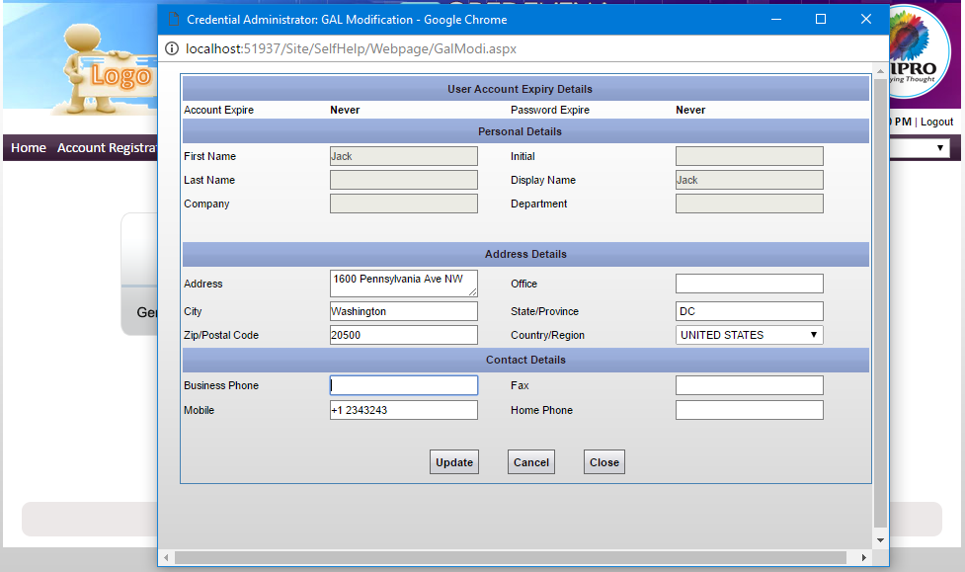

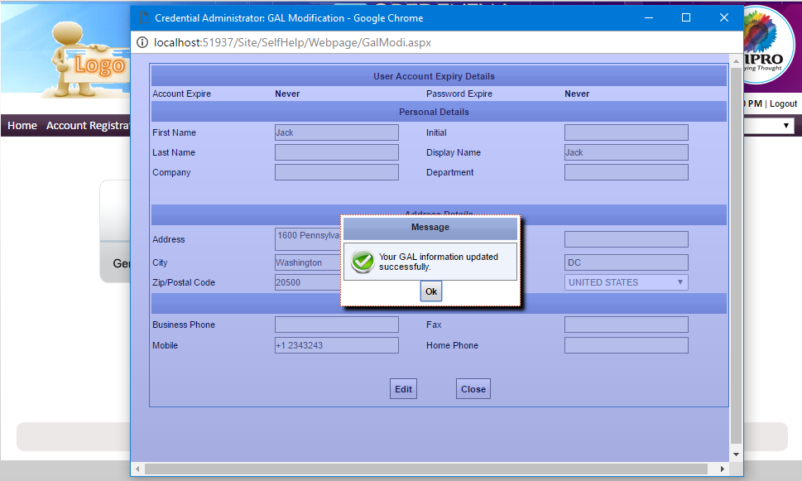

**Change Password**

**Click on “Change Password” button in Home page to change the password.**

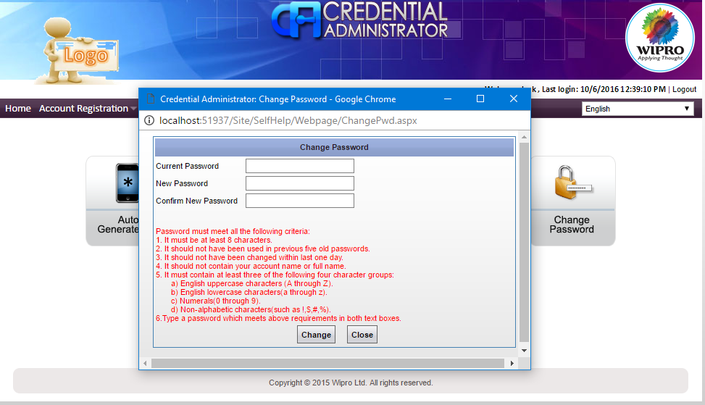

**Enter Current Password, New Password and Confirm Password same as New Password and click on change.**

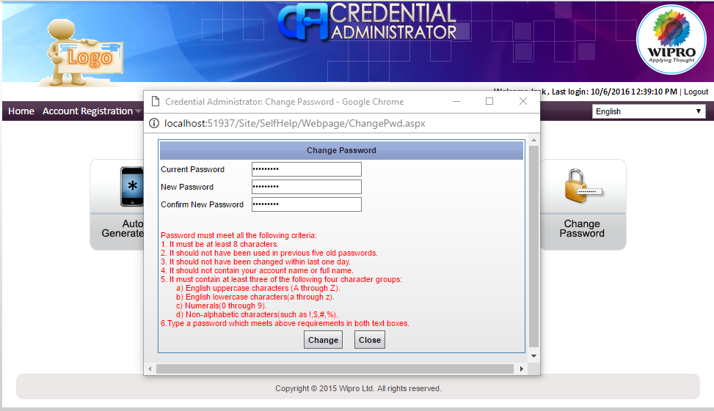

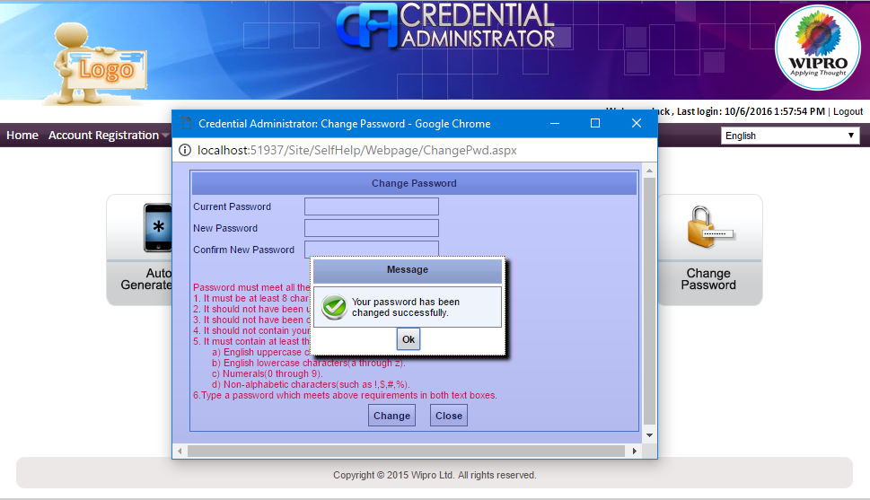

**5.Renew Account**

**Steps 1: Select Reportee from Reportee**

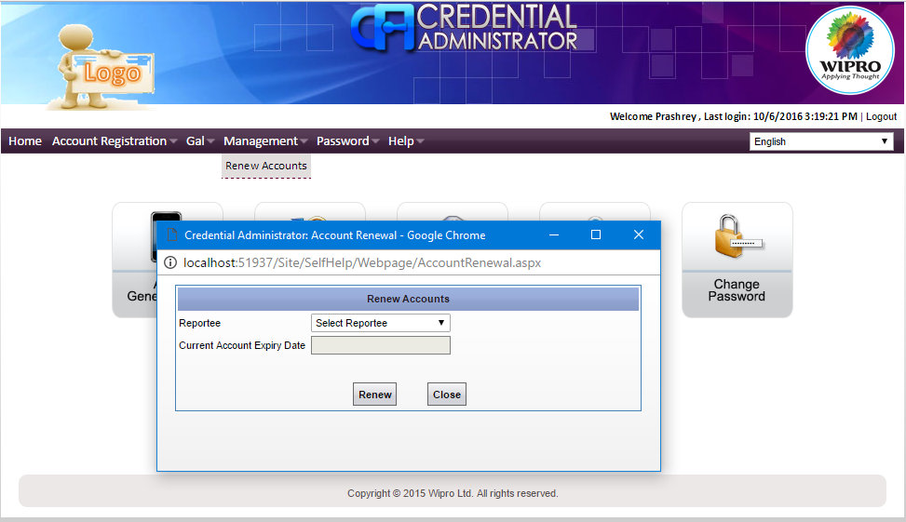

**Steps 2: Select Account Expiry Date and Click on Renew**

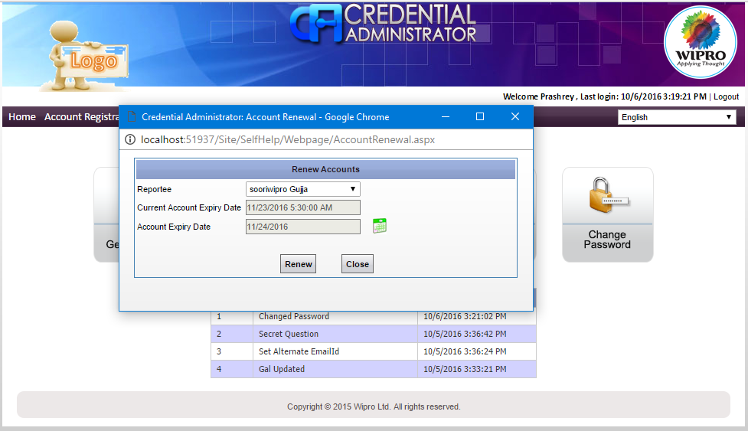

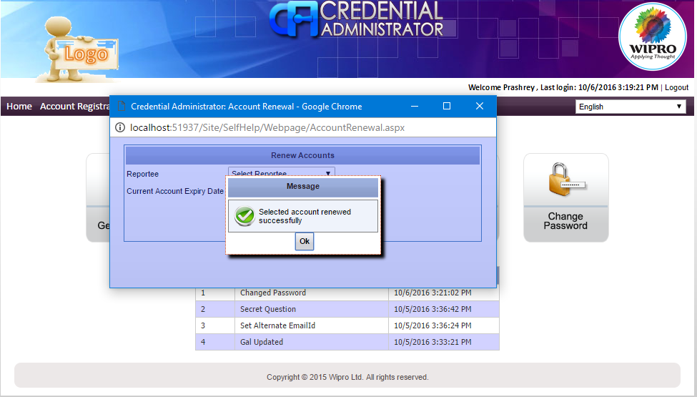

**6. Set alternate E-mail ID**

**Click on “Set Alternate Email ID” under “Account Registration” in main menu.**

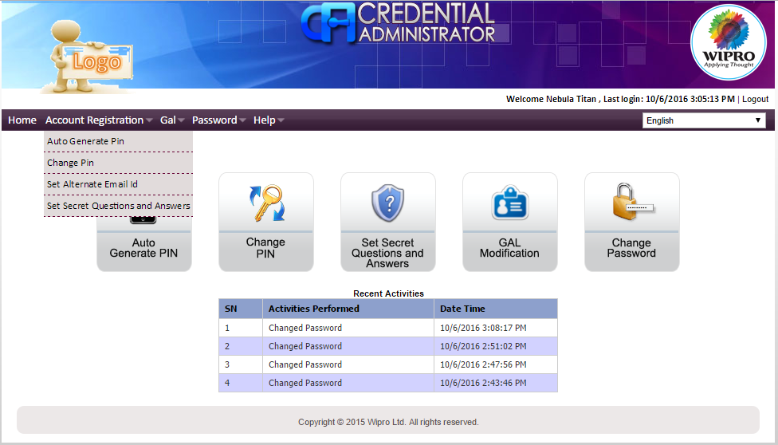

**Enter the alternate Email ID and click on save.**