**Credential Administrator**

**Help Document**





This document contains proprietary information of Wipro Ltd. No part of this publication may be reproduced, stored in a retrieval system or transmitted in any form or by any means, whether electronic, mechanical, photocopying, recording or otherwise, without the prior written permission of Wipro Ltd. The information contained herein is confidential between Wipro Ltd. and Customer and shall not be distributed to any persons other than those involved in the assessment and delivery of services. Wipro Ltd. reserves the right to revise and update this document as and when required. Wipro Ltd. reserves the right to withdraw the document excluding customer specific information at the time of termination of services.

 All product names referenced herein are trademarks of their respective companies.

**Table of contents**

1. How to login to the Credential Administrator Portal………………………3
2. Mandatory Account Registration for new user…………………………….4-6
3. Password Reset & Account Unlock ……………………...………………..7-9
4. GAL Modification & Change Password…………………………………….10
5. DL Modification ……………………………………………………………….11-13
6. SAP Unlock Password and reset…………………………………………….14-17

**1.How to login to the Credential Administrator Portal**

**Access URL in Browser and enter the login credentials using employee ID and password along with corresponding Domain to login.**

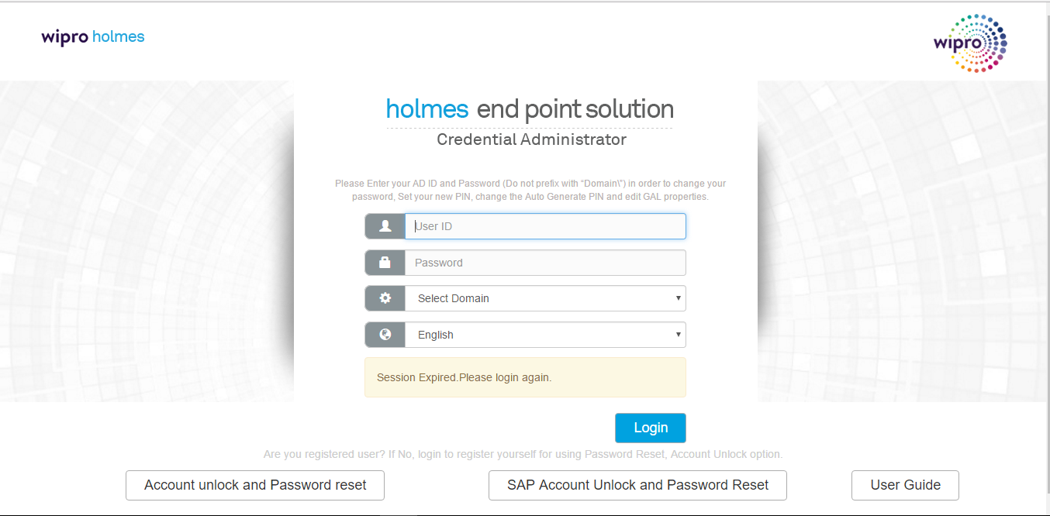

**2. Mandatory Account Registration for new user**

**Step1: For New user, once login , users will get below screen asking them to register themselves by setting PIN, Secret question & answer. Once click on ok, will be navigated to Home page.**

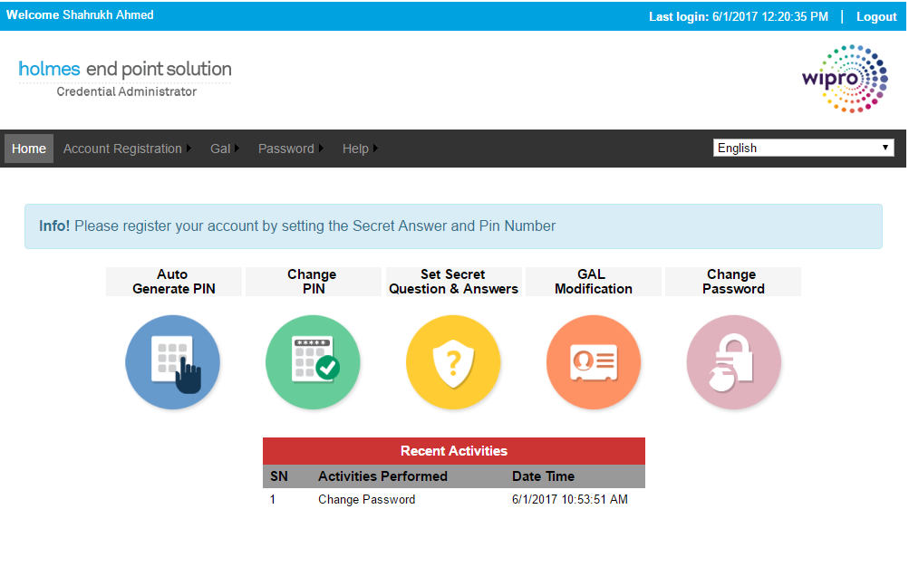

**Using “Account Registration” menu or “Auto Generate PIN” and “Set Secret questions and Answers” buttons users can register themselves.**

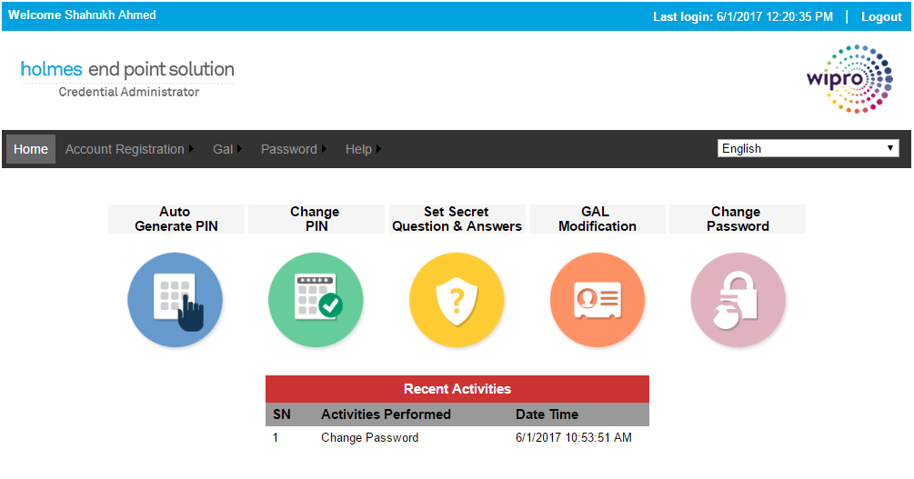

**Step2: Click on “Auto Generate PIN” image in Home page to generate new PIN number. PIN number will be displayed as a pop up message with expiry date as 30 days. Auto generated PIN should be taken to change PIN as users choice**

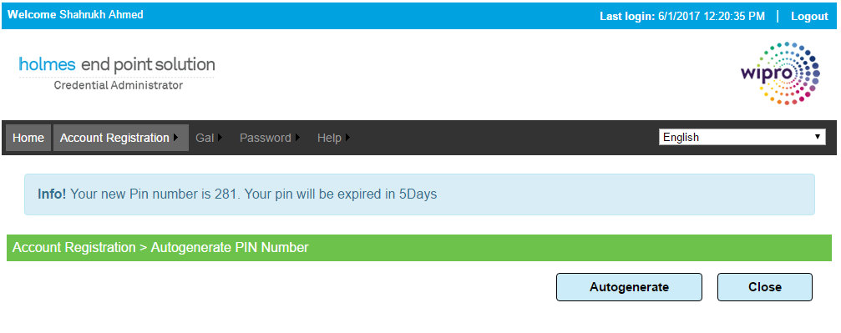

**Change PIN**

**Click on “Change PIN” button in Home page to change PIN as of users choice. Enter Current PIN Number which was auto generated and then New PIN Number and click on Reset**

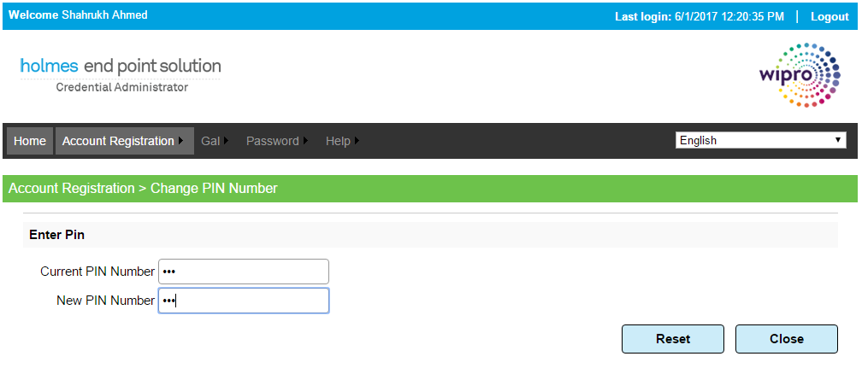

**Set Secret Question and Answer**

**Click on “Set Secret Question and Answers” image in Home page to set answers for default secret questions. Secret questions cannot be set with duplication**

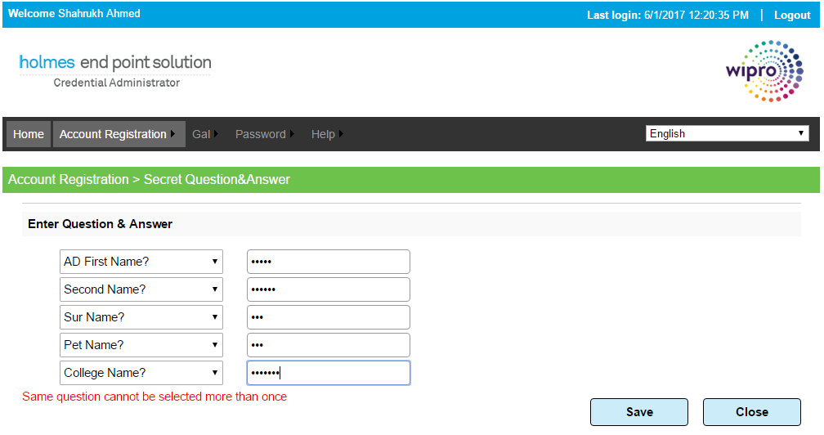

**3.Account Unlock/Password Reset**

**Click on “Password Reset/Expiry” in login page to reset the password using PIN mechanism.**

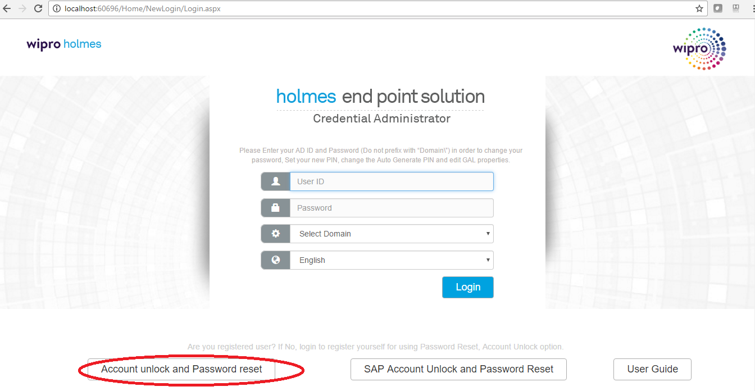

**Step1: Enter User Id and captcha image details and click on verify to proceed further**

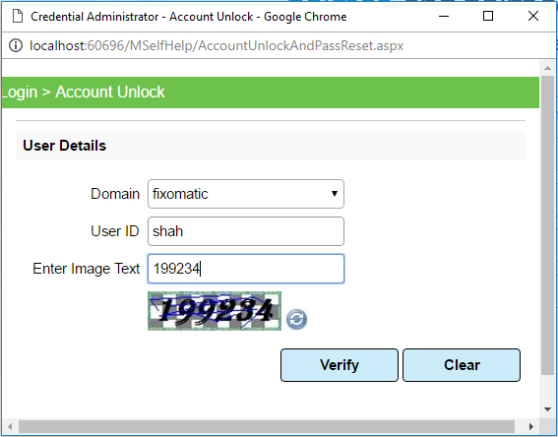

**Step2: Enter PIN number and click on validate**

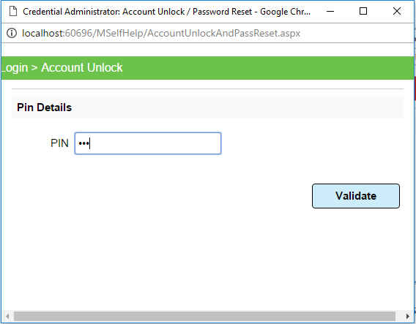

**Step3: Enter answer for randomly generated secret question and click on validate**

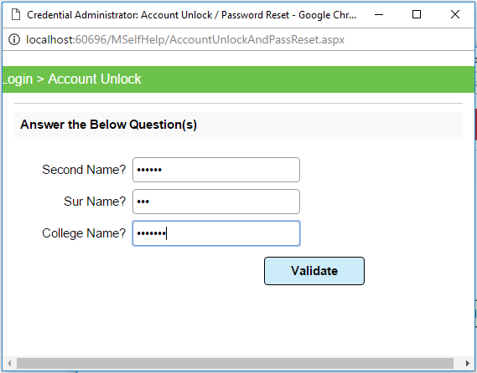

**Step4: Enter New Password and Confirm Password and click on Reset.**

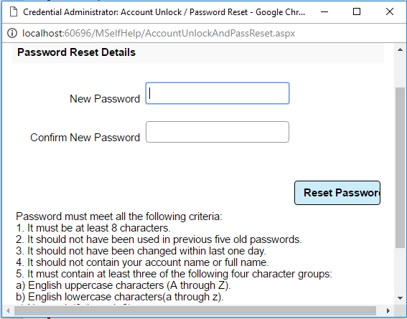

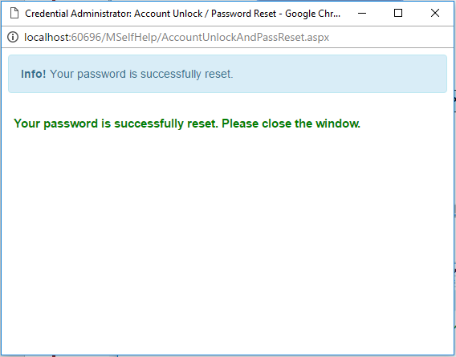

**4.GAL Modification**

**Steps: Click on “GAL Modification” in Home page and click on edit button to edit details in GAL modification page. Modify the details and click on update button**

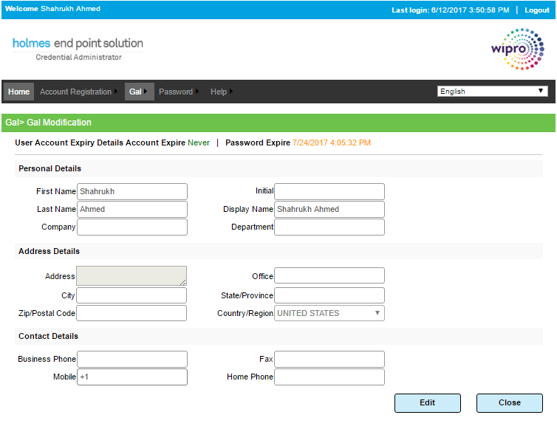

**Change Password**

**Click on “Change Password” button in Home page to change the password. Enter Current Password , New Password and Confirm Password same as New Password and click on change**

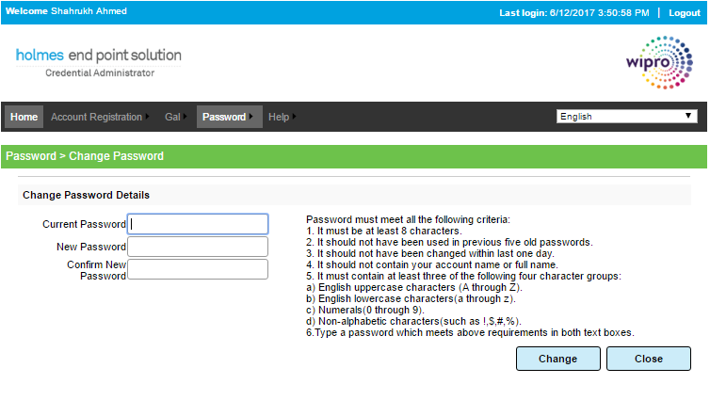

**5.DL MODIFICATION**

**Steps1: Go to Menu and Click on DL Modification**

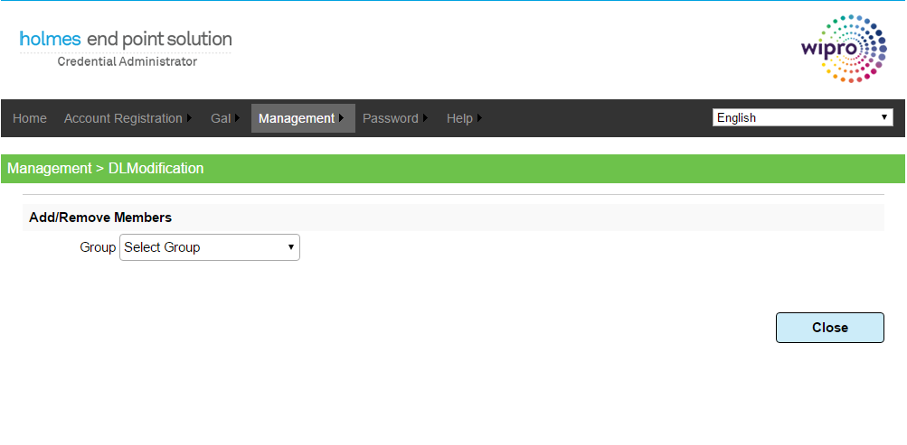

**Steps 2 : Select Group from Group**

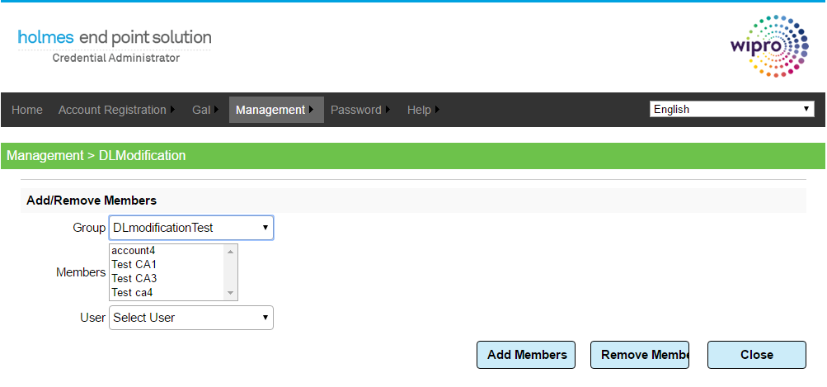

**Add Members:**

**Steps 3: Select User from User and click on Add Members to add the user to Group.**

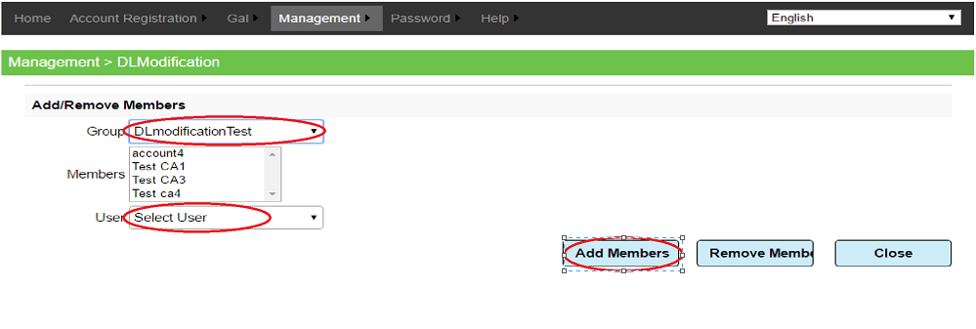

**Remove Members:**

**Steps 3: Select the members from Members and click on Remove Members to remove the members from the group**

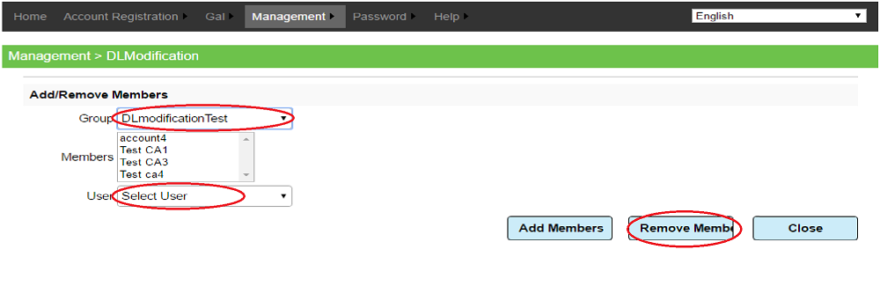

**Renew Account:**

**Steps 1: Select Reportee from Reportee**

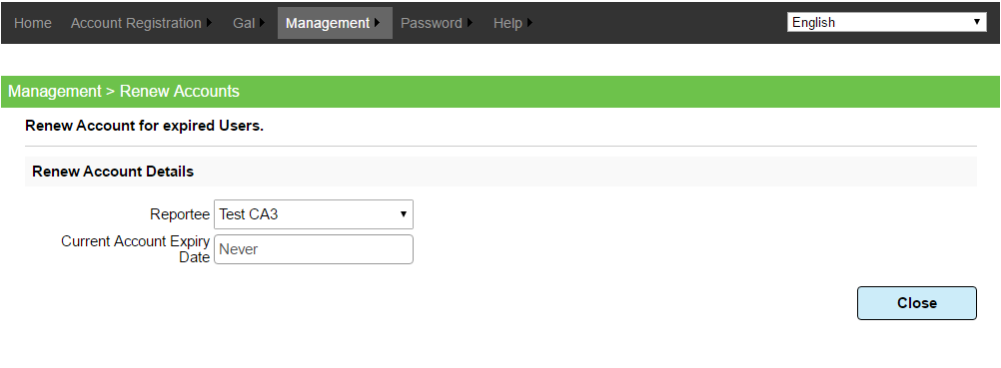

**Steps 2: Select Account Expiry Date and Click on Renew**

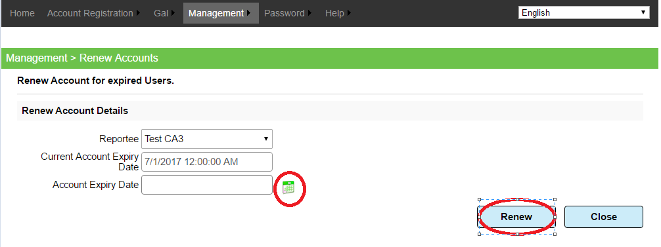

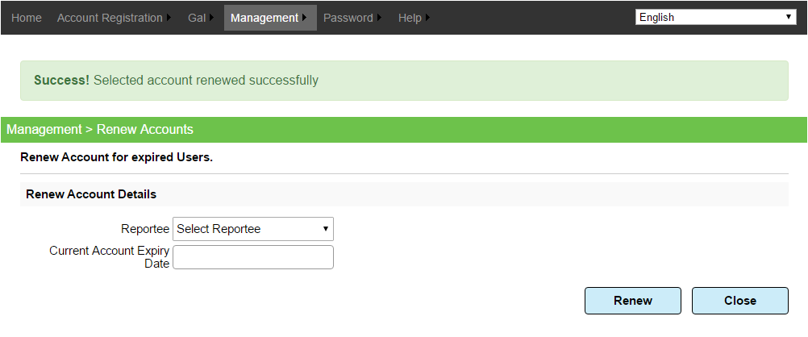

**6.SAP Account Unlock/Password Reset**

**Click on “Password Reset/Expiry” in login page to reset the password using PIN mechanism.**

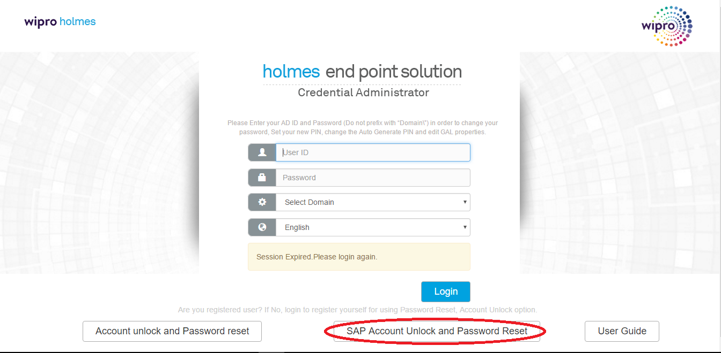

**Step1: Enter User Id and captcha image details and click on verify to proceed further**

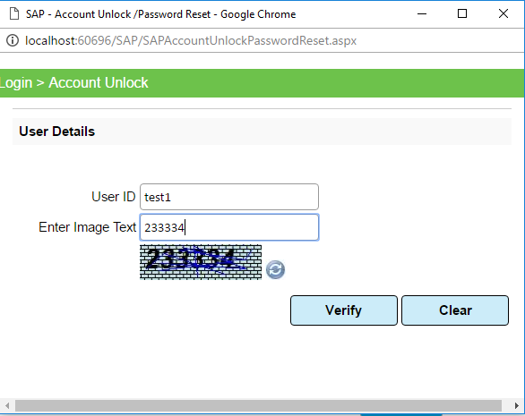

**Step2: Enter PIN number and click on validate**

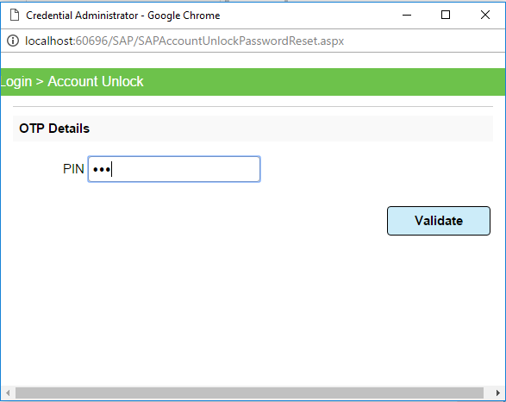

**Step3: Enter answer for randomly generated secret question and click on validate**

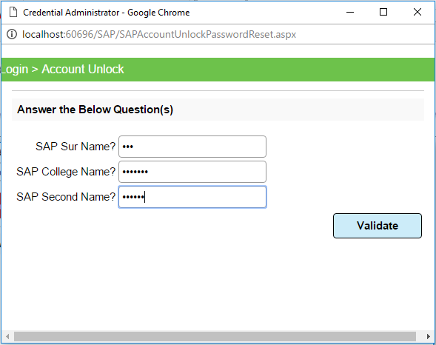

**Step4: Click on Reset Password button.**

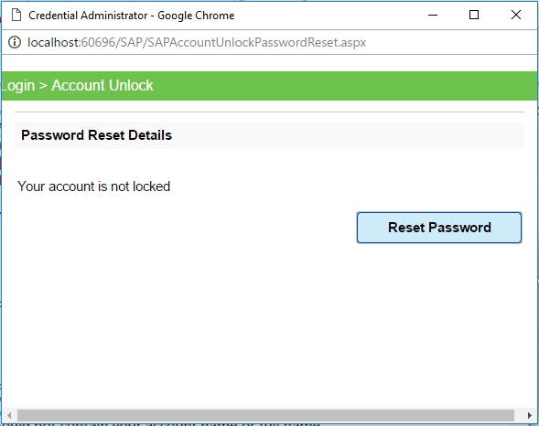

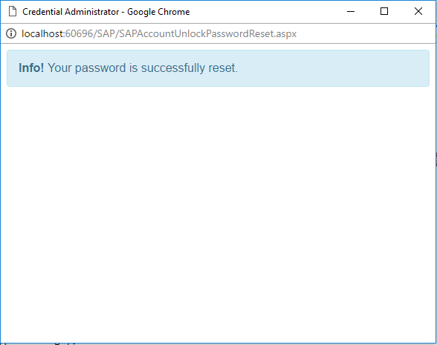

**Change Password**

**Click on “Change Password” button in Home page to change the password.**

**And Click on change on redirected screen.**

